IBDP Chemistry
Topic 15 Energetics (HL)
Notes
15.1 Standard Enthalpy of Changes of Reaction

15.1.1
Standard state – the state of an element at 298K and 1 atm. Remember, which elements are solid? Liquid? Gas? Which are diatomic (example H₂)? (HOFBrINCl).

Standard enthalpy change of formation (ΔH_{f}^{Θ}) is the amount of energy released or absorbed in the formation of one mole of the substance, in its standard state, from elements in their standard states. Calculated like this:

ΔH^{Θ} = Σ ΔH_{f}^{Θ}_{products} – Σ ΔH_{f}^{Θ}_{reactants}

Standard enthalpy change of combustion (ΔH_{c}^{Θ}) the enthalpy change when one mole of a substance undergoes complete combustion in excess oxygen under standard conditions.
Example:
CH₄(g) +O₂(g) CO₂(g) +2H₂O(l) ΔH_{c}^{Θ} = -891 kJ/mol

*Note: why is water a liquid in the combustion equation? It is a liquid under standard conditions (298K and 1 atm), so for standard enthalpy change of combustion, energy is listed for the production of liquid water. However, in reality, the water would change to a gas due to the heat released in combustion.

15.1.2
See enthalpy of change of a reaction worksheet. These problems are a lot like Hess’s law, you just have to write your own equations for combustion and formation, which isn’t that hard!

15.3 Born-Haber Cycle

Standard Enthalpy of of Change of Atomization is the enthalpy change needed to make one mole of atoms of an element in the gas phase from the element in the standard state. Example for Na

Na(s) Na(g) ΔH_{at}^{Θ} = +103 kJ/mol

15.2.1 Define and apply these:

Electron affinity is the enthalpy change when a mole of atoms or ions in the gas phase gains a mole of electrons to form negatively charged ions in the gas phase.
Cl(g) + e⁻ Cl⁻ (g) ΔH^{Θ} = -364 kJ/mol

*Note: Cl usually exists as a molecule (Cl₂), so be careful to always write the atom or ion when writing an electron affinity equation.
Lattice enthalpy is the enthalpy needed to convert a compound into its ions in the gas phase.
NaCl(s) Na⁺(g) + Cl⁻(g) ΔH^{Θ} = +771 kJ/mol

Figure 1: The Born-Haber cycle for the formation of sodium chloride.

ΔH^{Θ} of formation of NaCl = -441 kJ/mol
ΔH^{Θ} of atomization of Na = +103 kJ/mol
ΔH^{Θ} of atomization of Cl = +121 kJ/mol
ΔH^{Θ} of electron affinity of Cl = -364 kJ/mol
ΔH^{Θ} Ionization energy of Na = +500 kJ/mol

Enthalpy of atomization + Elec. affinity + enthalpy ionization = enthalpy of formation + lattice energy
Lattice energy -411 = 103 +121 -364 +500
Lattice energy = 411+103 +121 -364 +500

*Try using Hess’s law to solve this question too, in case you forget the equation.

15.2.4
There are two ways of determining lattice enthalpy for compounds.
- Empirical value: experimentally measured using Born-Haber cycle.
- Theoretical value—this is based on the ionic bonding theory. Calculated by adding electrostatic attractive and repulsive forces between ions in the crystal lattice.

For ionic compounds that have a large difference in electronegativity, the theoretical calculation works well.
For compounds that have some covalent character (less than 1.7 difference in electronegativity), the theoretical value is lower than the empirical value because covalent character increases lattice energy.

Table 1: Experimental (determined by Born-Haber cycle) and theoretical lattice enthalpies for some compounds.
Compound | Empirical value (kJ/mol) | Theoretical valcue (kJ/mol)
KBr | 672 | 667
AgI | 865 | 736

15.3 Entropy

We learned that exothermic reactions are more likely to happen. Enthalpy is a kind of

The entropy of a system is a measure of the degree of disorder or randomness in a system. It has the symbol, “S” and units are J/K•mol. It is thought of as probability. A state with higher entropy has a higher probability of existing.

Entropy values of states of water. Ice: 48.0 J/K•mol. liquid water: 69.9 J/K•mol. Liquid water has a higher entropy, so if a water molecule has enough kinetic energy (temperature above 0°C), it has a high probability of being a gas.

ΔS = ΣS(products) –ΣS(reactants)
(It’s like calculating ΔH)

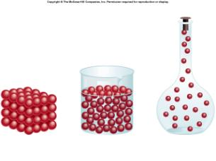
15.3.1-2
Entropy increases…
- With greater motion, freedom of movement and speed.
- With an increase in the number of particles (molecules or atoms).
- Mixing substances

Greater Motion:
- Solids: lowest entropy. Solids have a fixed arrangement, but then can move a little, so they have some entropy.
- Liquids: more entropy than solids. Particles in a liquid can move more freely than in a solid.
- Gases: most entropy. Gas molecules can move fast and intermolecular forces are low because they are so far apart.
Image from: http://qwickstep.com/search/liquid-solid-and-gas.html

  - Therefore the following phase changes have an increase in entropy, or a positive ΔS
H₂O(s ) H₂O(l) + ΔS
H₂O(l) H₂O(g) + ΔS

  - And these phase changes would have a negative ΔS
H₂O(l) H₂O(s) - ΔS
H₂O(g) H₂O(l) - ΔS

- Increase in temperature = increase in entropy because particles have more kinetic energy and have more rapid motions.

Greater number of particles
- When the number of moles of products is more than the moles of reactants, entropy increases. Dissociation reactions always have a positive ΔS

NaCl(s) Na⁺ + Cl⁻ + ΔS

- Precipitation reactions have a – ΔS because solid is produced and the number of particles decreases.

15.3.3 Calculating entropy change
ΔSº_{reaction} = ΣS(products) –ΣS(reactants)

You can look up standard entropy values in the data booklet during the written test (paper 2).

The following example is from: http://www.science.uwaterloo.ca/~cchieh/cact/applychem/entropy.html

Evaluate the entropy change for the reaction:
CO + 3 H₂ -> CH₄ + H₂O
in which all reactants and products are gaseous.
Solution.
The entropies are given below the formula of the reactants and products: (data are given in 3 significant digits)
CO + 3 H₂ -> CH₄ + H₂O
198 131 186 189
ΔS = ((186 + 189) - (198 + 3*131)) J (K mol)⁻¹
= -216 J (K mol)⁻¹
Discussion
There are four (4) moles of reactants and two (2) moles of products (all in gaseous state), hence the large negative change in entropy for the reaction.
15.4 Spontaneity
15.4.1 Predict whether a reaction is spontaneous or not by looking at the sign of ΔG^{Θ}

The spontaneity of a reaction refers to whether or not it can occur without any special conditions. Spontaneous reactions can occur.

Reactions with + ΔS and - ΔH are always spontaneous. However, you know that some reactions with a positive ΔH happen (endothermic reactions).

Example: dissolving NH4Cl is endothermic, but it can happen at room temperature.

Why? ΔS must be large enough.

Gibbs free energy change ΔG takes into account both ΔH and ΔS

ΔG = ΔH^{Θ} – TΔS^{Θ}

-ΔG = spontaneous

Table 2: The effect of ΔH and ΔS on ΔG and the spontaneity of the reaction.
ΔH^{Θ} | ΔS^{Θ} | ΔG | Spontaneity
Positive, endothermic | Positive | Depends on T | Spontaneous at high enough temperatures TΔS must be greater than ΔH
Positive, endothermic | Negative | Always positive | Never spontaneous
Negative, exothermic | Positive | Always negative | Always spontaneous
Negative, exothermic | Negative | Depends on T | Spontaneous at low enough temperatures, TΔS must be lower than ΔH
*This assumes that ΔS^{Θ} and ΔH^{Θ} will not change much with a change in temperature.

15.4.2 Calculating ΔG^{Θ}
The following is taken from http://www.chem.tamu.edu/class/majors/tutorialnotefiles/gibbs.htm
Sample free energy calculation (standard-state conditions):
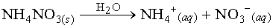
Compound | H_{f} | S
NH₄NO_{3(s)} | -365.56 | 151.08
NH₄⁺_{(aq)} | -132.51 | 113.4
NO₃⁻_{(aq)} | -205.0 | 146.4
CalculateH,S, andG for the above reaction to determine whether the reaction is spontaneous or not.
First let's calculateH_{f}. Note that in the above reaction, one mole of NH₄NO₃ dissociates in water to give one mole each of NH₄⁺ and NO₃⁻:
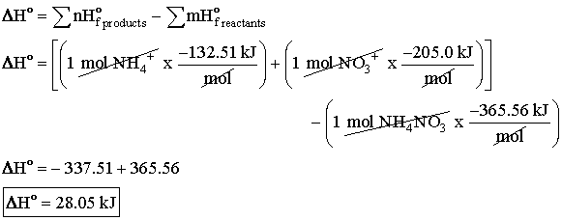
Next, let's calculateS:
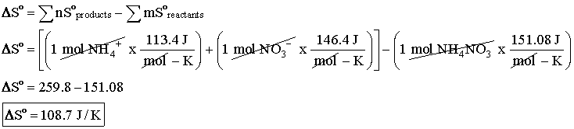
Now we can plug in these values we've calculated into the free energy equation.
NOTE: The units of H_{f} is kJ and the units of S is J/K. Since G is generally reported in kJ, we can divide S by 1000 to convert it to units of kJ/K
NOTE: The temperature in the free energy equation must be in Kelvin, so we must convert the given temperature in Celsius to Kelvin by adding 273.15.
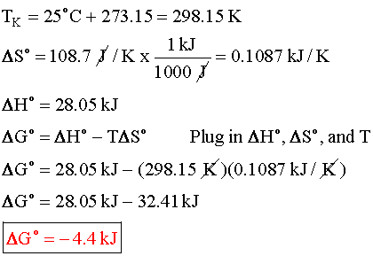
15.4.3 ΔG can also be calculated from ΔG^{Θ}_{f}, similar to how you use ΔH^{Θ}_{f}
ΔG^{Θ}_{f} = ΣΔG^{Θ}_{f} (products) - ΣΔG^{Θ}_{f} (reactants)

